Analog Communication Report

**Done by Ahmed Magdy**

**ID: 210901**

TA: Eng. Mira Mohsen  
ML: Prof. Mohamed Abdullatif

**Introduction:**

In this lab, we will be required to simulate an analogue communication system using Matlab in two stages: first, we will simulate the required circuit using Simulink, and then we will simulate our data in the discrete time system using graphs.   
We will compare our signal in its original form, after passing through a filter, and after adding another signal generated by a random source.   
The stop band of the signal will also be recorded via screenshots, and the frequency of the sin wave will be recorded by switching between nine different values that are less than the value of the stop band.   
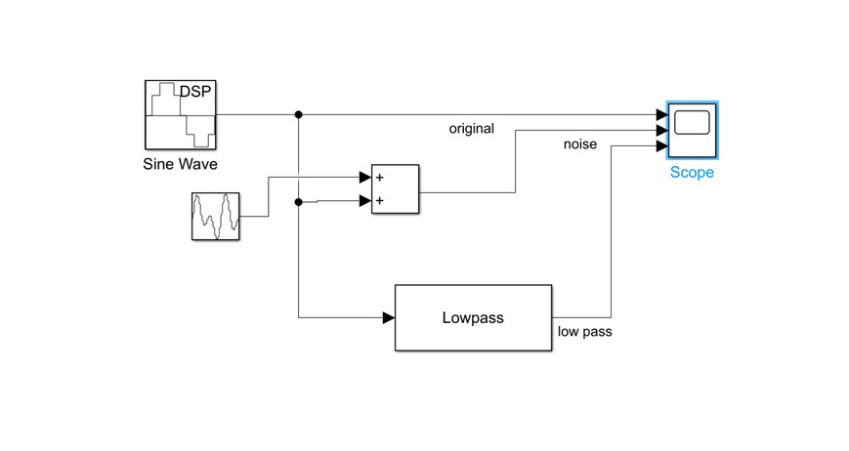

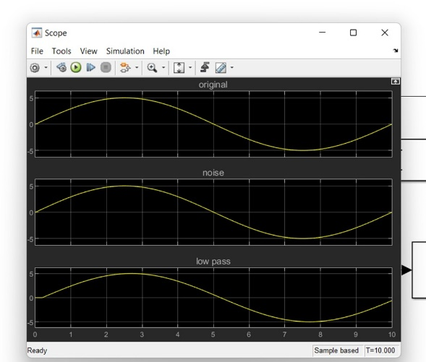

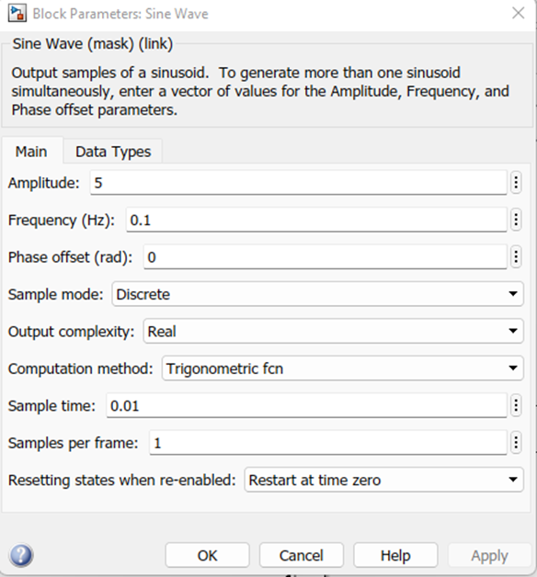

1. Signal with analog filter

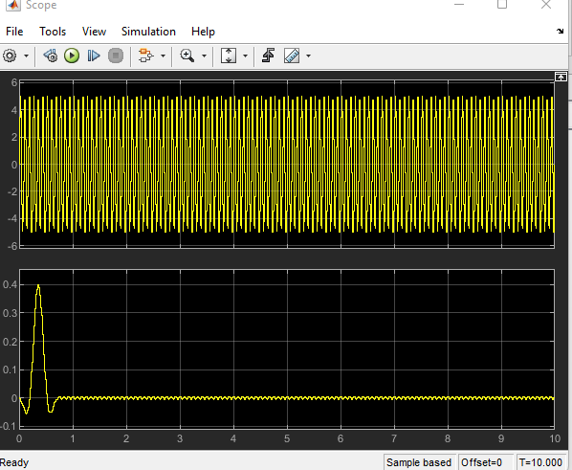This is the output of the simulation of the signal after finding the stopband of the signal at 12 Hz

* **The following outputs are obtained after switching the value of the frequency of the sin wave, which is less than the value of the stopband:**

1. At 10 Hz

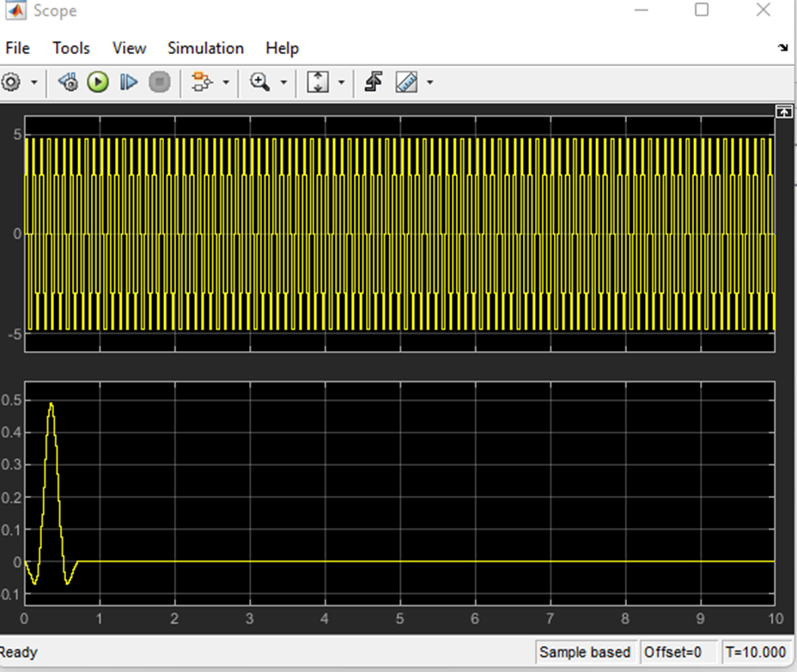

2. **at 9 Hz**



**3. at 8 Hz**

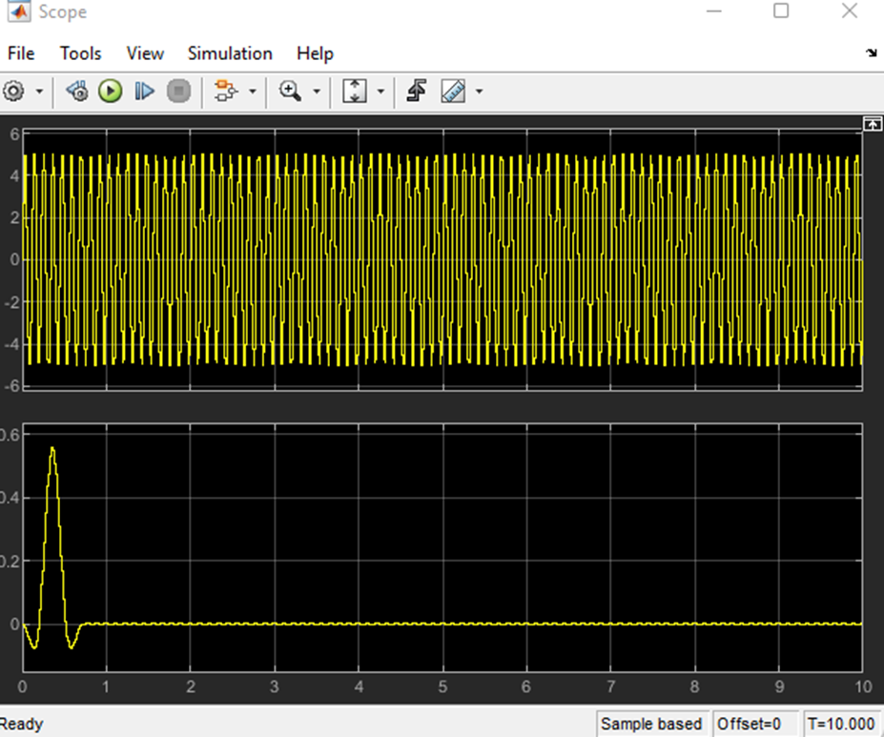

4. **at 7 Hz**

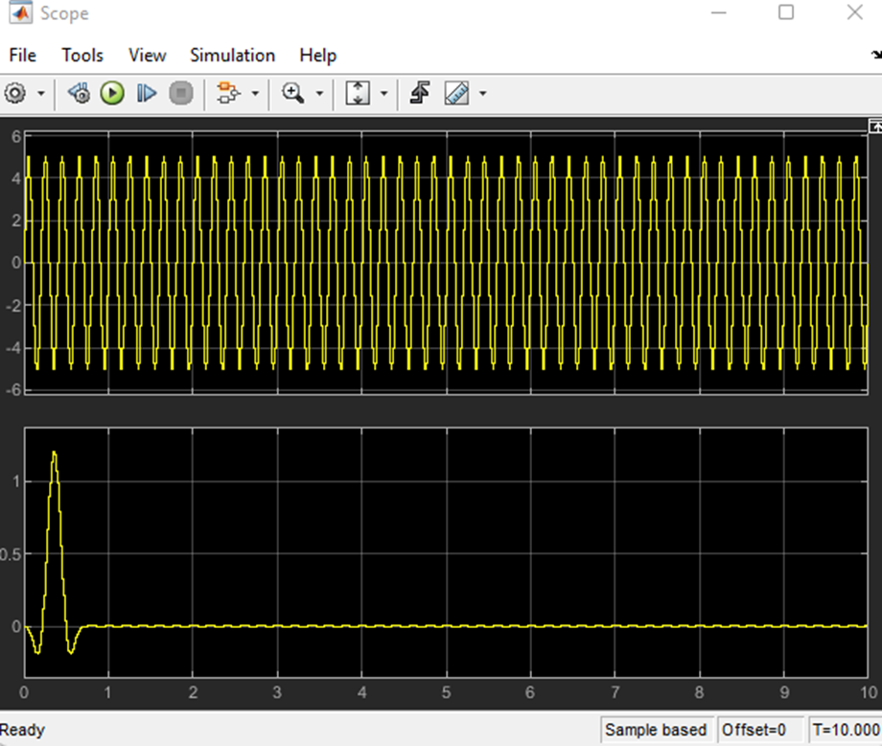

* **After adding random source**

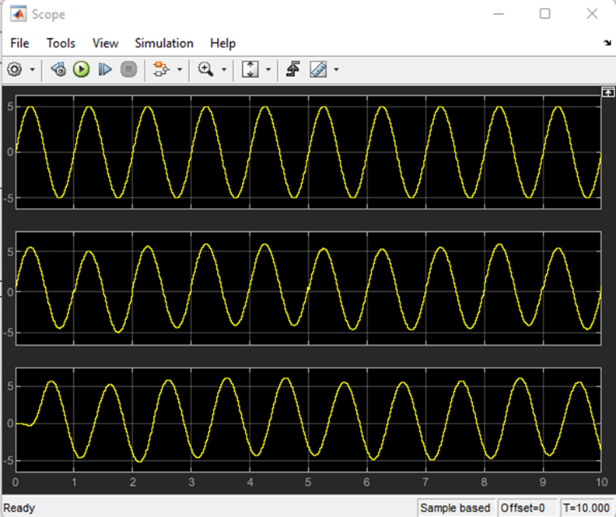

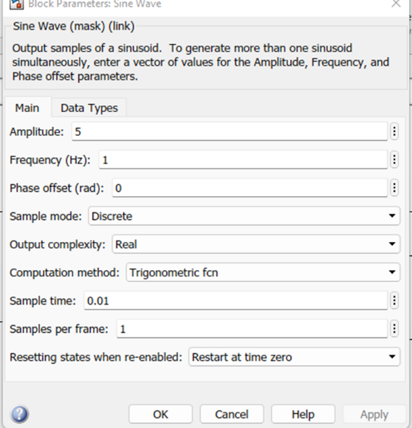

Stop band is at 40 Hz

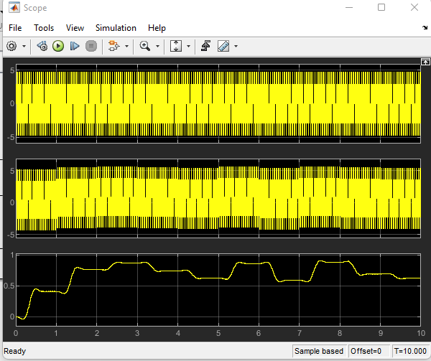

At frequency 35 Hz

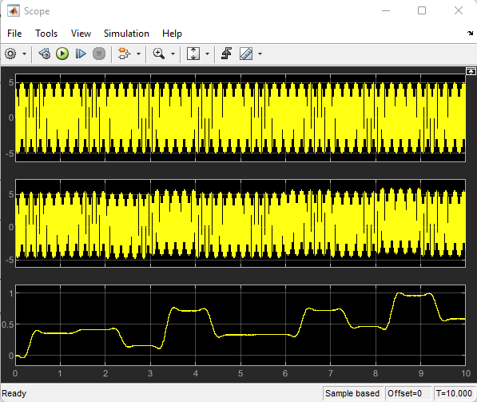

At 32 Hz

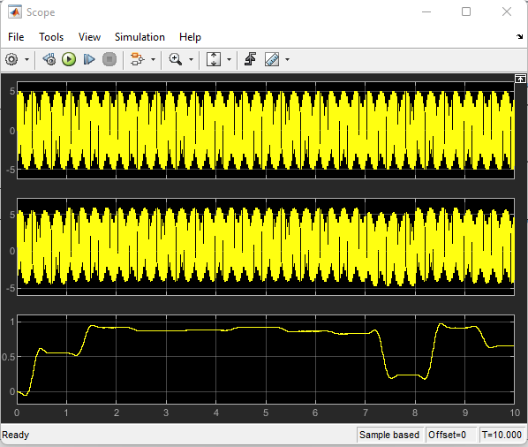

At 29 Hz

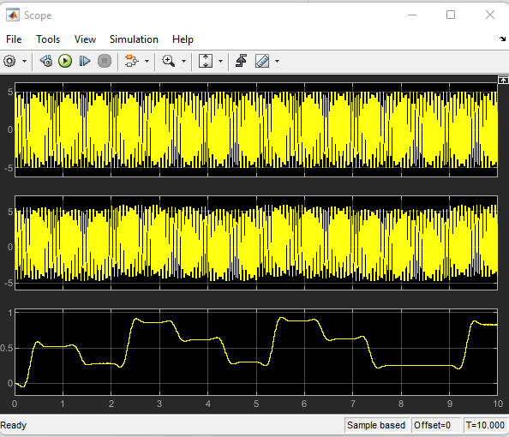

At 27 Hz

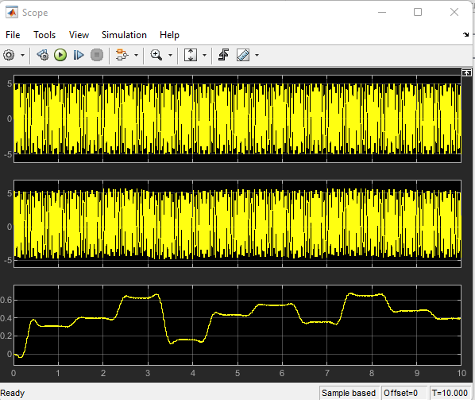

At 25 Hz

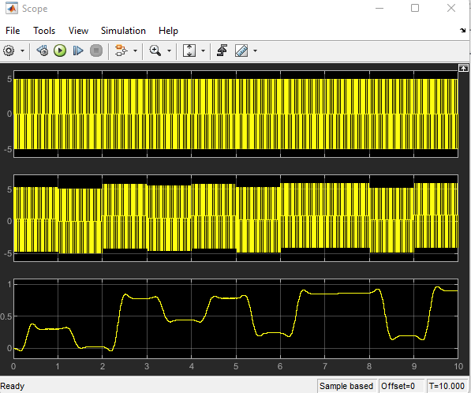

At 20 Hz

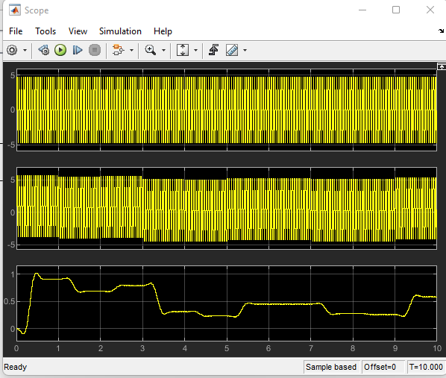

At 18 Hz

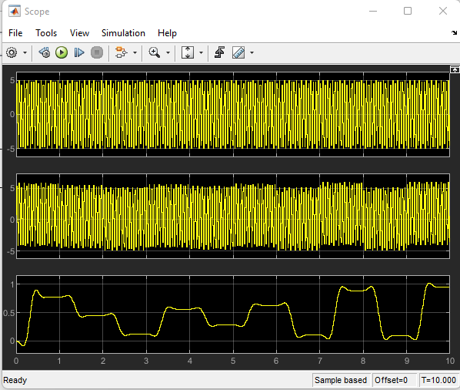

At 16 Hz

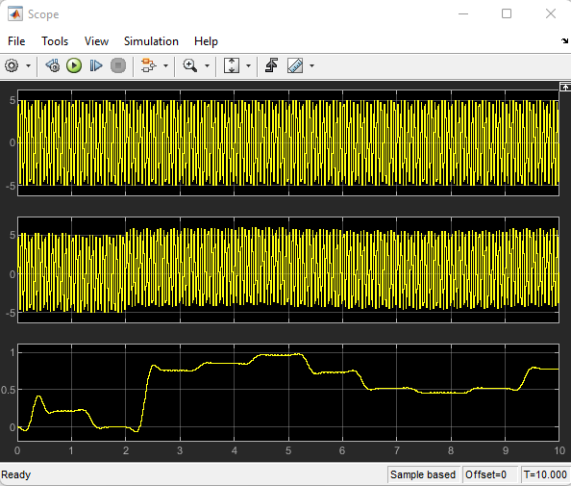

At 14 Hz

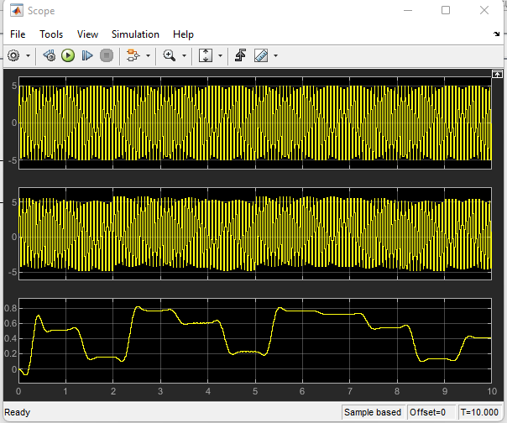

Lab 2

Introduction:

A modulating signal can be used to change the properties of a carrier signal. Modulation is the name given to this procedure. The modulated signal is the end result of the modulation process, while the modulating signal is the base band signal.

The two Main target of the lap:

1. To follow the modulation process and to operate AM to modify the carrier signal's amplitude

2. To study the effects of multiplying the carrier by the modulating signal and to take note of the sidebands that occur.

**Task 1: AM Modulation, Section1:**

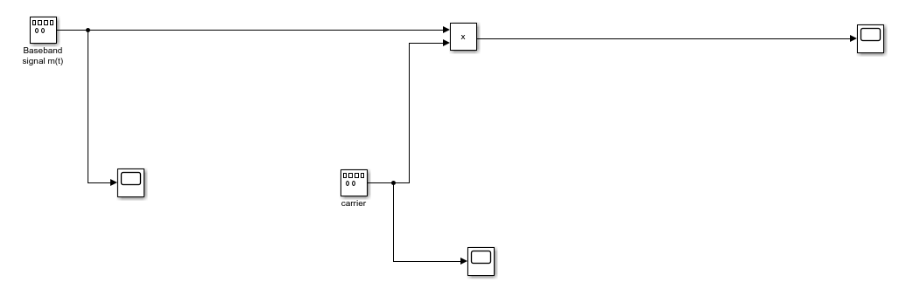

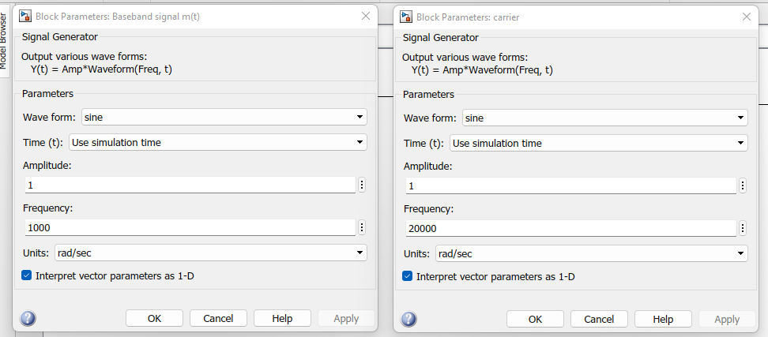

We use 2 different amplitudes in baseband signal and for each amplitude 4 different frequencies for each amplitude

1. Baseband signal m(t)

Amplitude equal (1)

At Frequency 1000

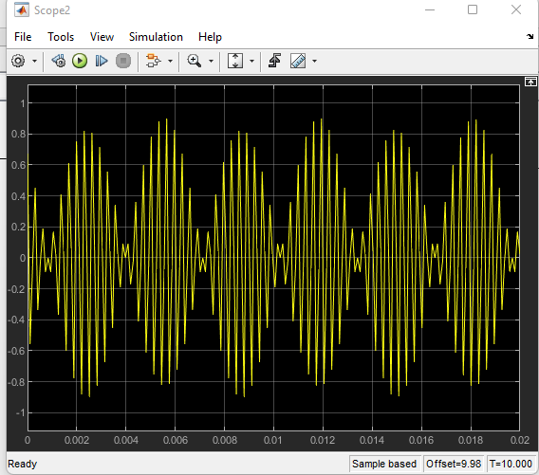

At frequency 2000

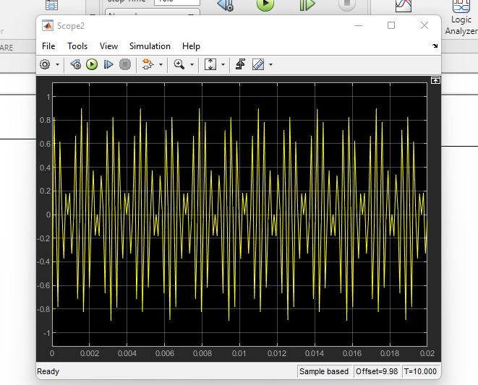

At frequency 3000

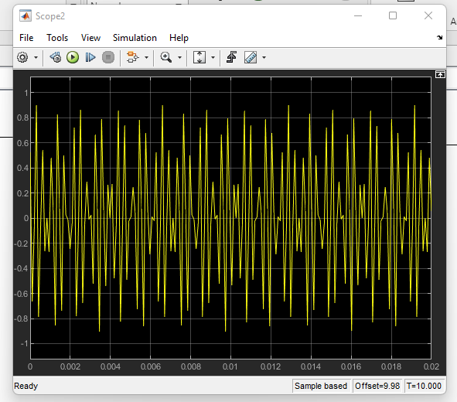

At frequency 4000

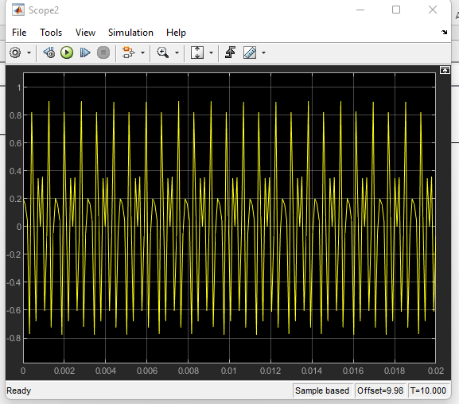

At frequency 5000

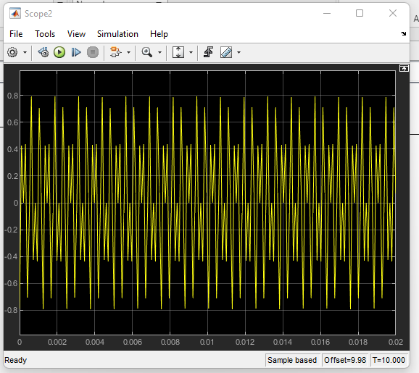

Amplitude equal (5)

At frequency 1000

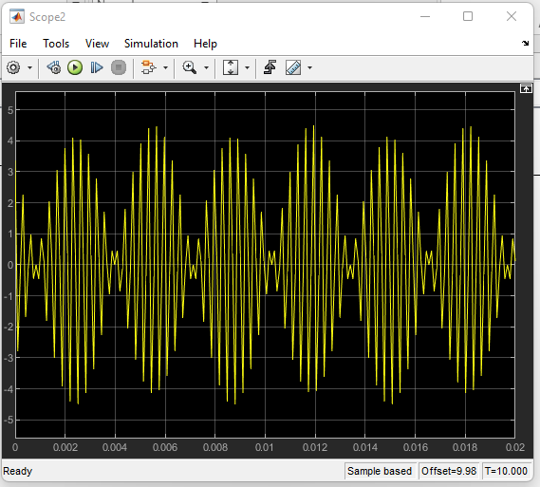

At frequency 2000

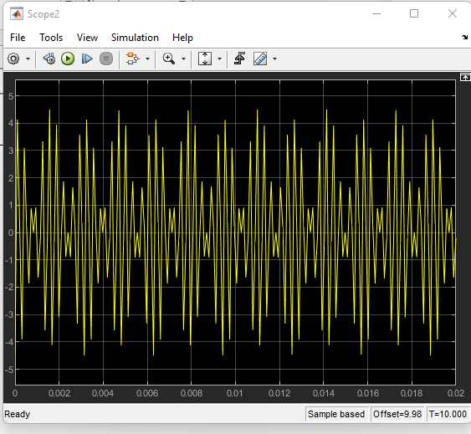

At frequency 3000

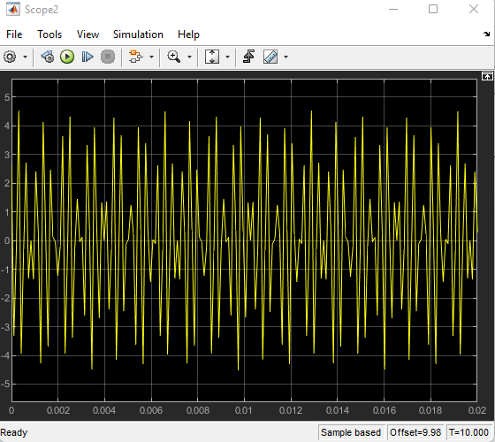

At frequency 4000

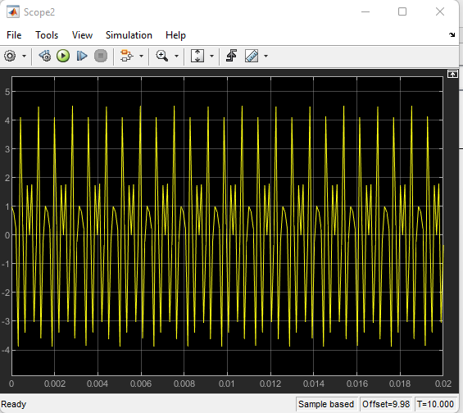

At frequency 5000

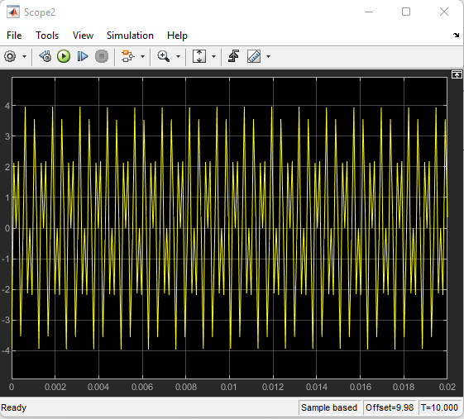

2. Carrier signal

Amplitude equal (1)

At Frequency 20000 Hz

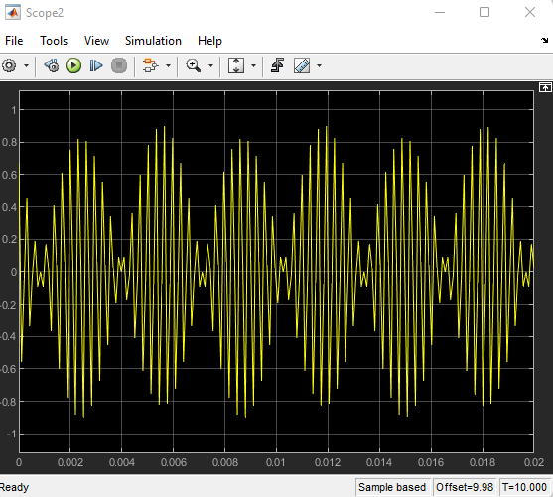

At frequency 30000 Hz

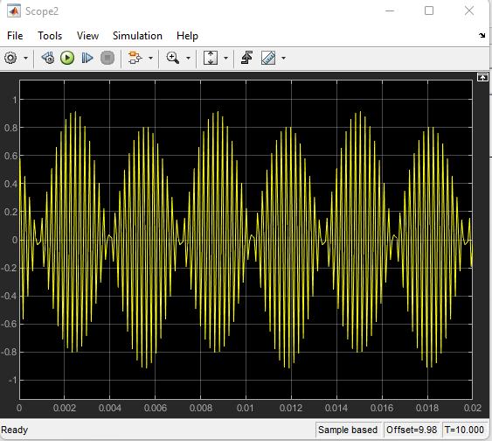

At frequency 40000 Hz

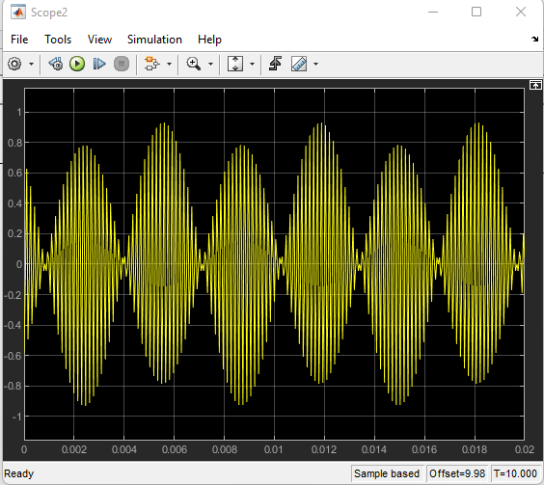

At 50000 Hz

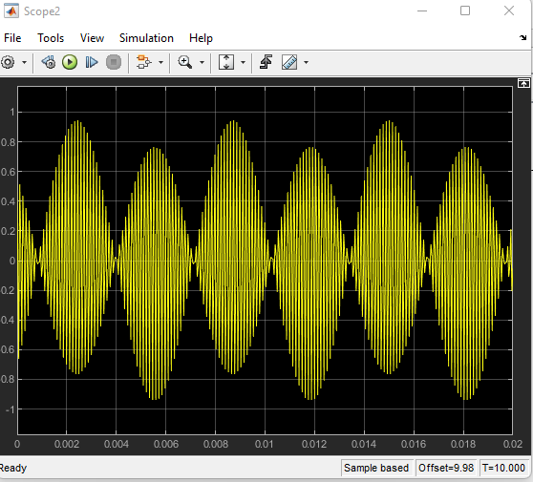

Amplitude equal (5)

At frequency 20000 Hz

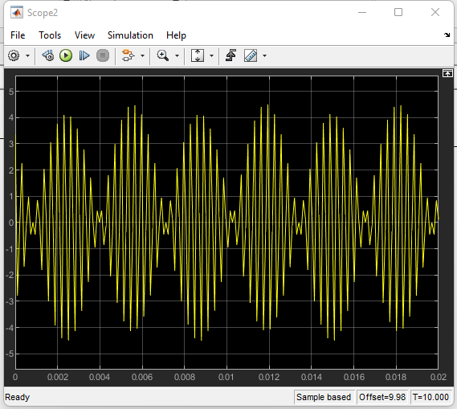

At frequency 30000 Hz

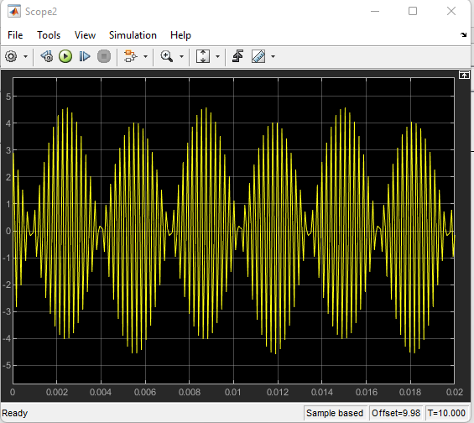

At frequency 40000 Hz

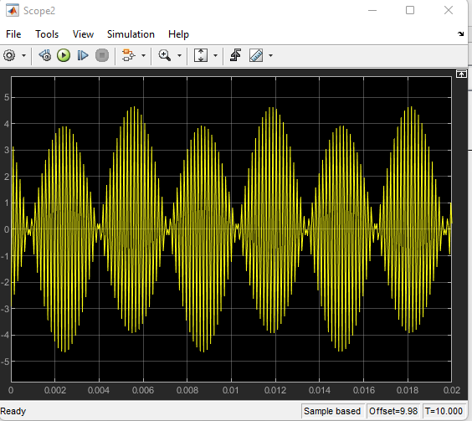

At frequency 50000 Hz

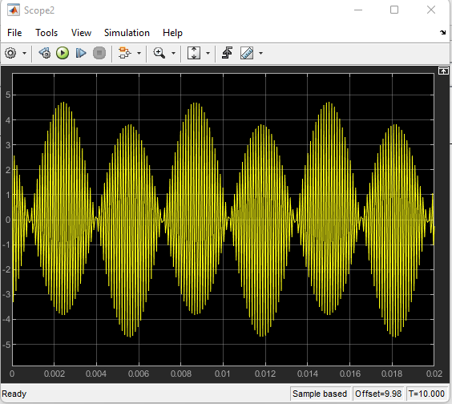

**Task 2**

AM Modulation

The gain is changed from 0.2 to 1 by the rating of 0.2 and at each number different four frequency values for taken for the baseband signal

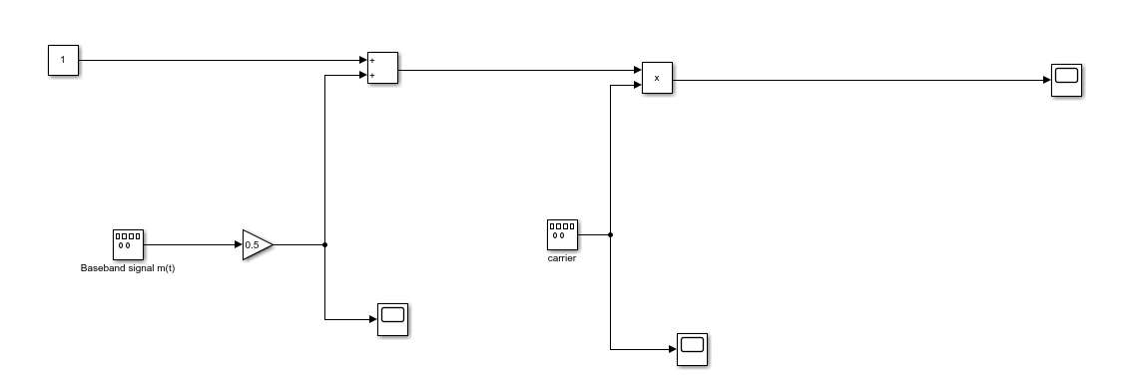

Gain is (0.2)

At frequency 1000 Hz

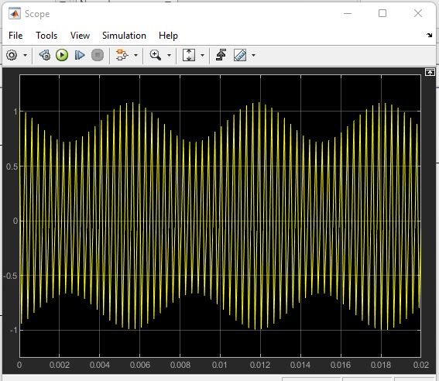

At frequency 2000 Hz

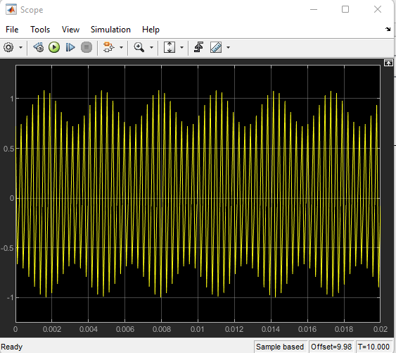

At frequency 3000 Hz

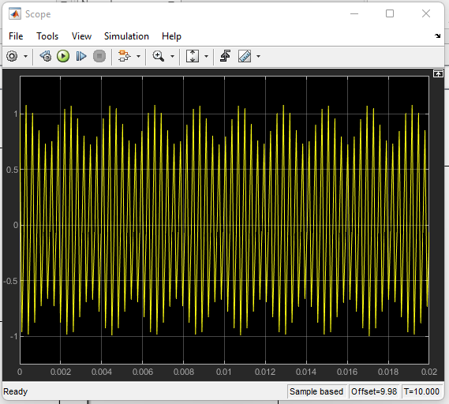

At frequency 4000 Hz

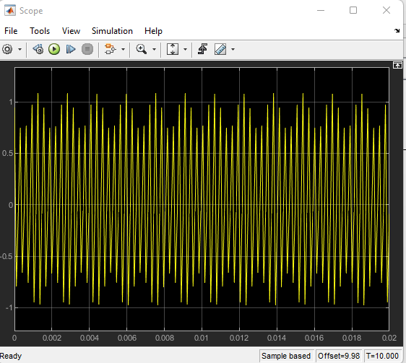

Gain is (0.4)

At frequency 1000 Hz

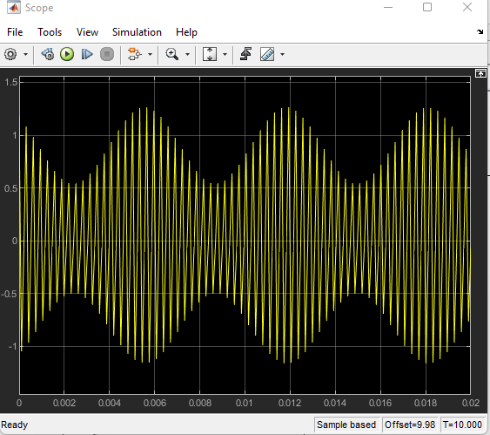

At frequency 2000 Hz

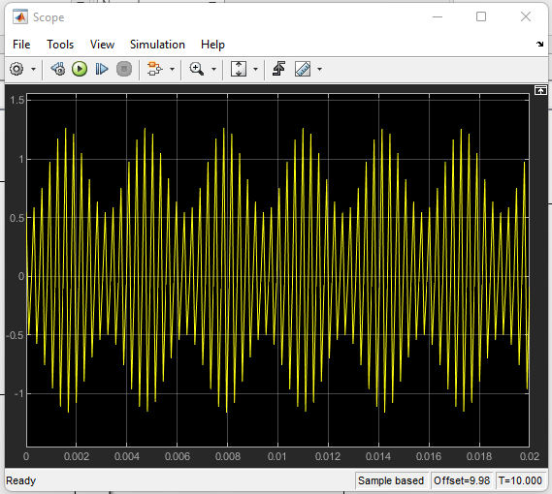

At frequency 3000 Hz

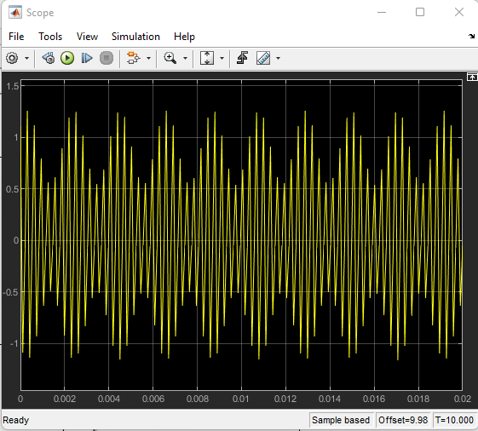

At frequency 4000 Hz

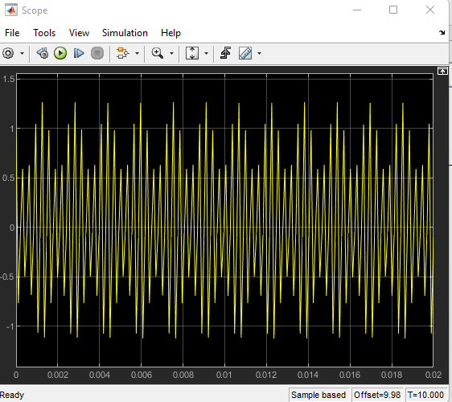

Gain is (0.6)

At frequency 1000 Hz

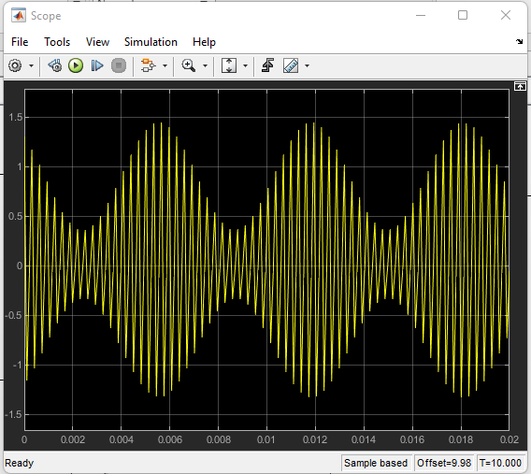

At frequency 2000 Hz

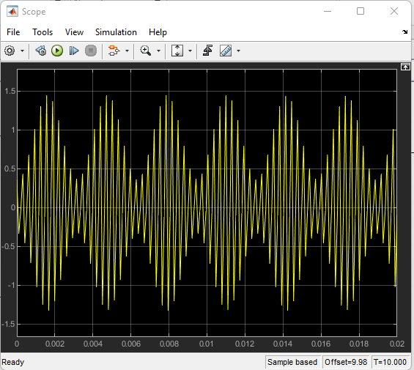

At frequency 3000 Hz

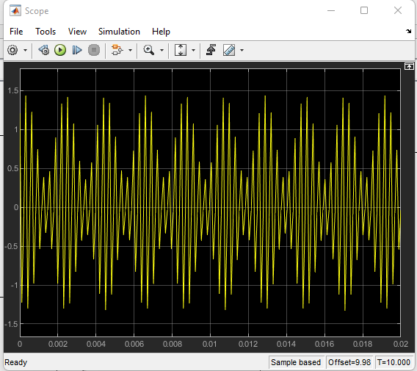

At frequency 4000 Hz

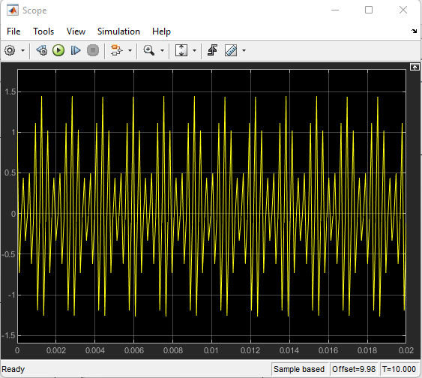

Gain (0.8)

At frequency 1000 Hz

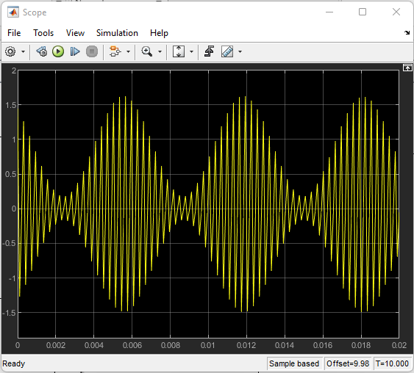

At frequency 2000 Hz

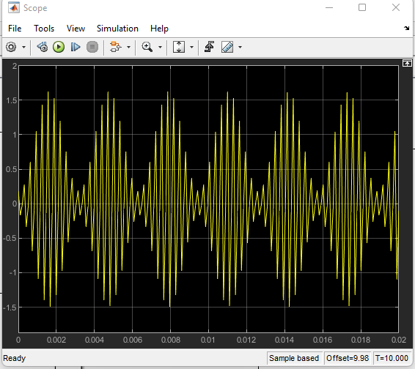

At frequency 3000 Hz

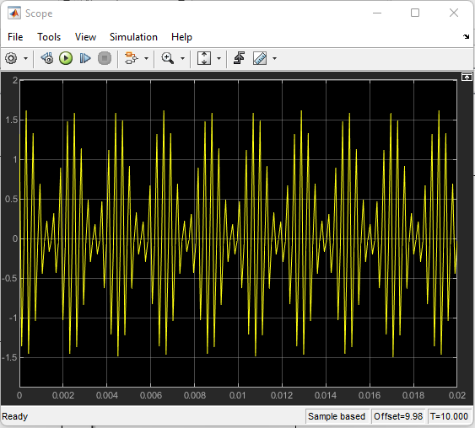

At frequency 4000 Hz

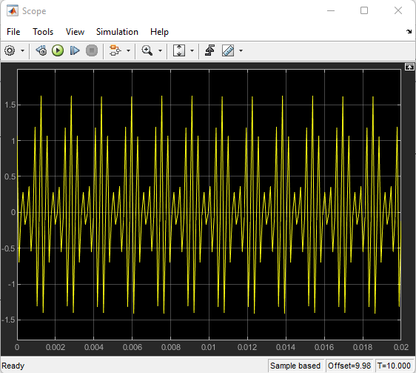

Gain (1)

At frequency 1000 Hz

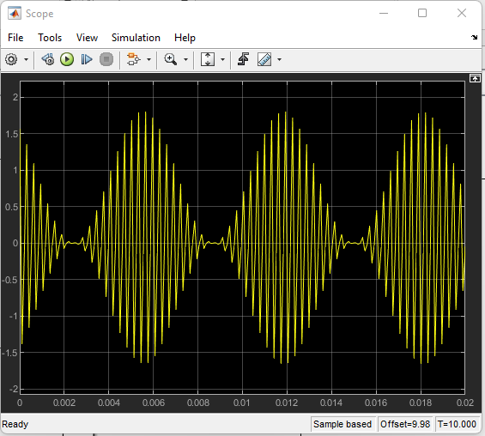

At frequency 2000 Hz

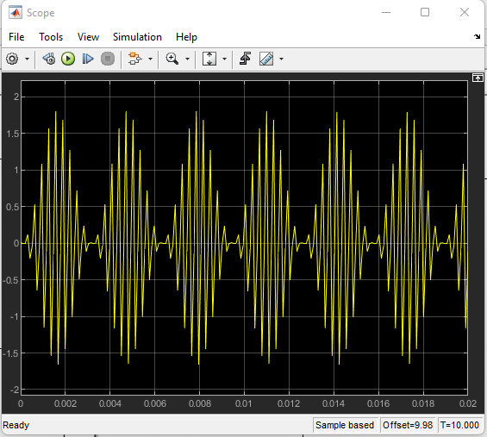

At frequency 3000 Hz

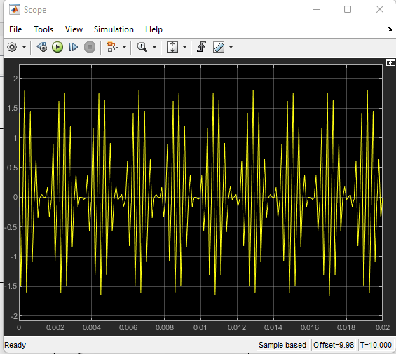

At frequency 4000 Hz

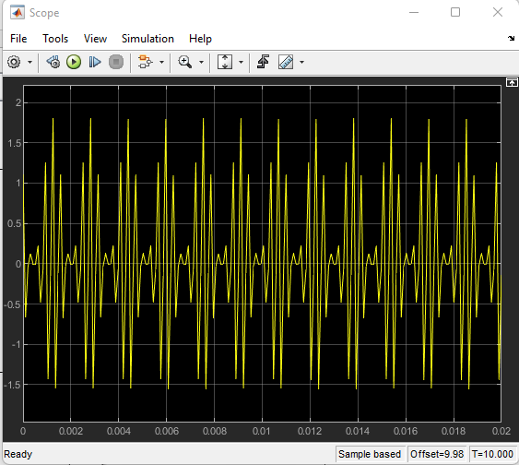

**Task 3**

## (DSB-SC Demodulation)

We gone use 4 different frequency of the baseband signal

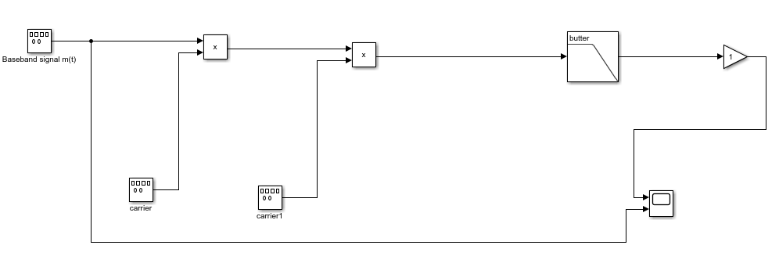

At 1000 Hz

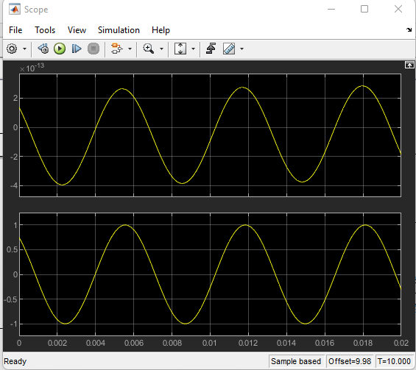

At 2000Hz

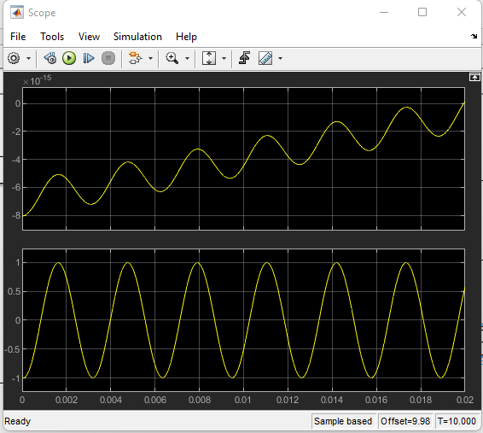

At 3000 Hz

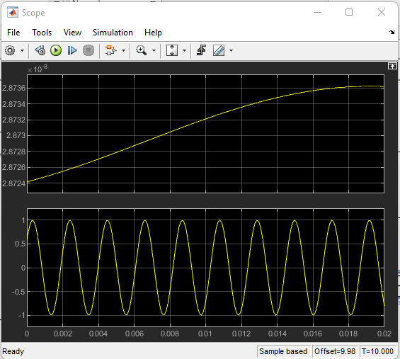

At 4000 Hz

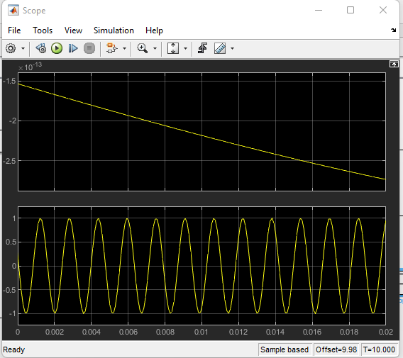

**Lab 3**

****Task 1****

****FM Modulation****

**Introduction:**

Frequency Modulation is the process where the amplitude of a modulating signal affects the frequency of the carrier signal.

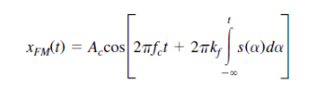

The main objectives of this lab assignment are:

* The objective is to understand and utilize the frequency modulation technique to modify the carrier signal.
* The Frequency Demodulation Process can be understood using a frequency discriminator.

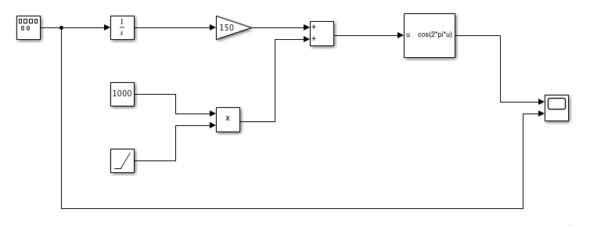

A Voltage-Controlled Oscillator (VCO) is an electronic oscillator with an output frequency inversely correlated with its input voltage, used in frequency and phase modulation by adding a modulating signal.

**This will result in the following display:**

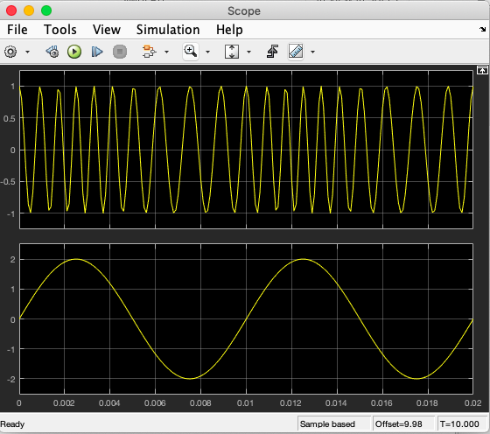

**Task 1** involves altering the message signal's frequency [m (t)] four times at different amplitudes, starting at Amplitude = 2. The VCO is represented by the block cos (2 x pi x u), where u is the input, and FM signal generation occurs in the Cosine Function block.

**At Frequency 50Hz**

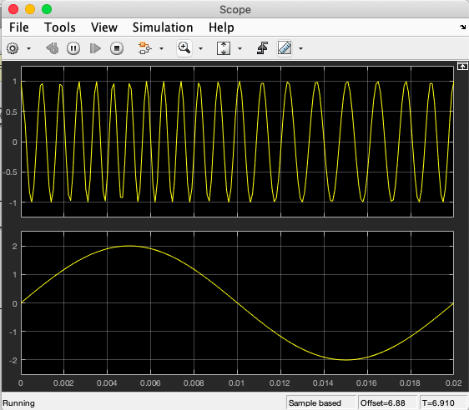

**AT Frequency 200Hz**

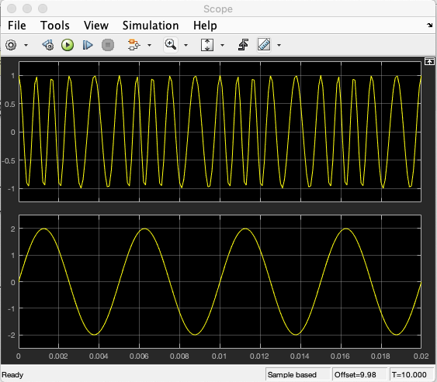

**AT Frequency 500Hz**

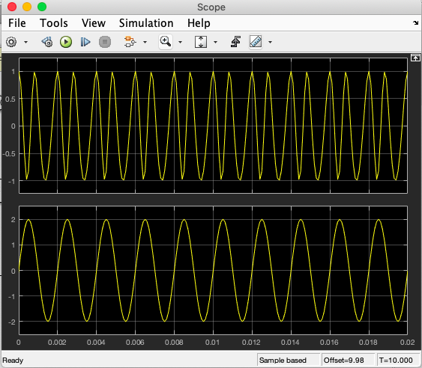

**AT Frequency 1000Hz**

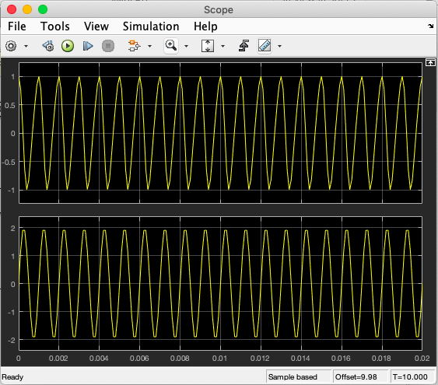

We will repeat the frequency four times, this time with a new Amplitude of m (t) = 4.

**AT Frequency 50Hz**

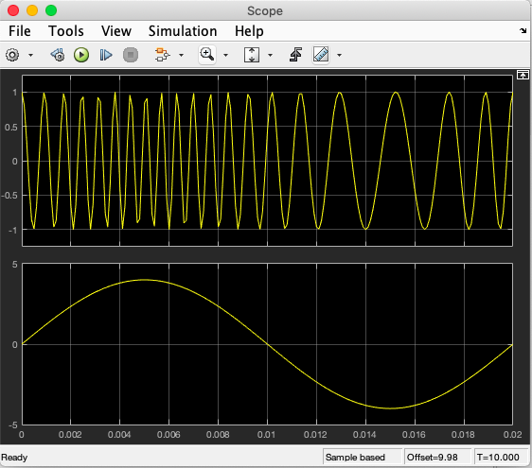

**AT Frequency 200Hz**

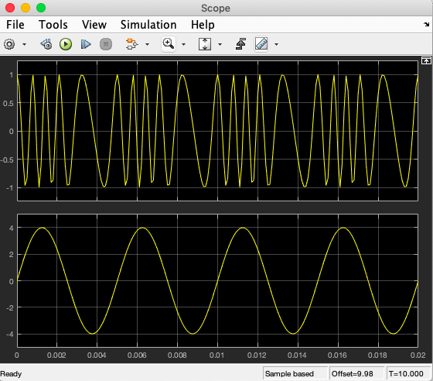

**AT Frequency 500Hz**

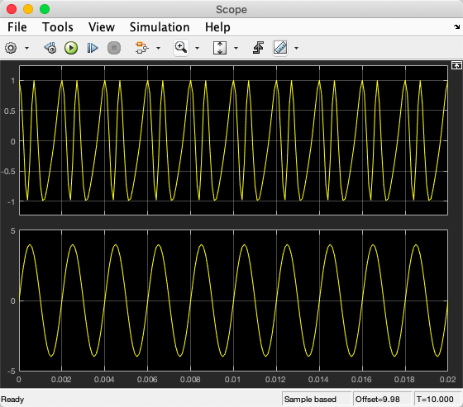

**AT Frequency 1000Hz**

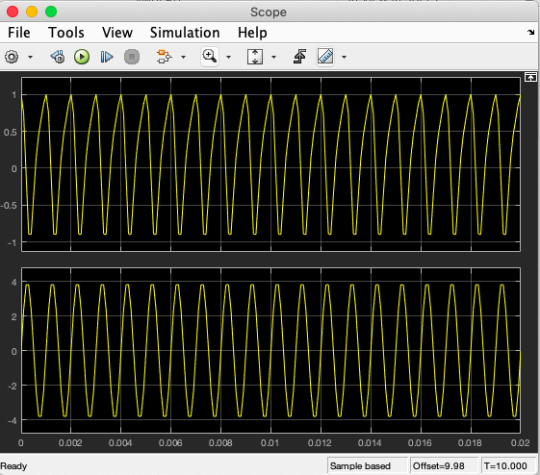

For the second half of Task 1, we will adjust the Frequency Deviation Constant (Kf) from 150 to four additional values by keeping m (t) at its default values. [Frequency 100Hz, Amplitude = 2]

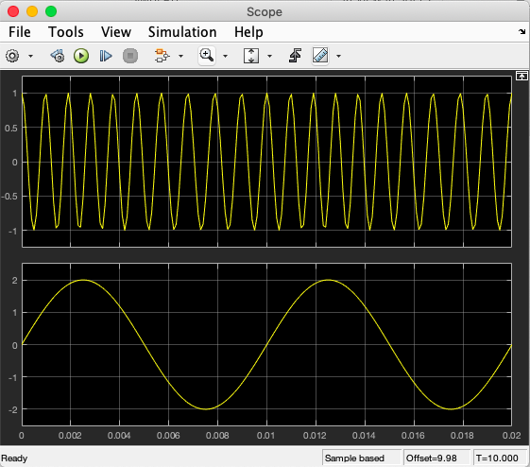**AT Frequency Deviation Constant (Kf)=50Hz/V**

**AT Frequency Deviation Constant (Kf)=100Hz/V**

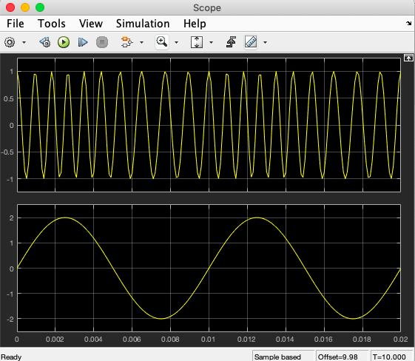

**AT Frequency Deviation Constant (Kf)=200Hz/V**

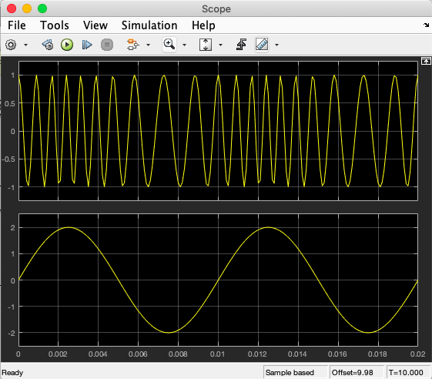

**AT Frequency Deviation Constant (Kf)=250Hz/V**

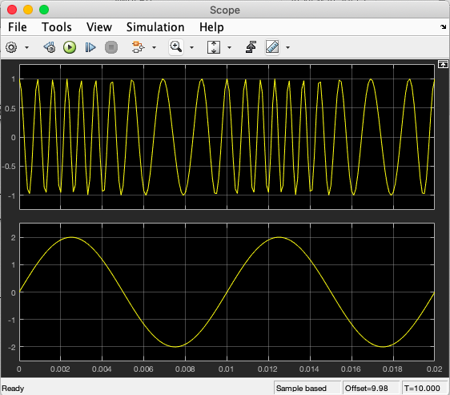

****TASK 2:****

****FM Demodulation****

We will create a connection diagram on MATLAB for Frequency Demodulation (FM) using following parameters for the Analog Filter block.

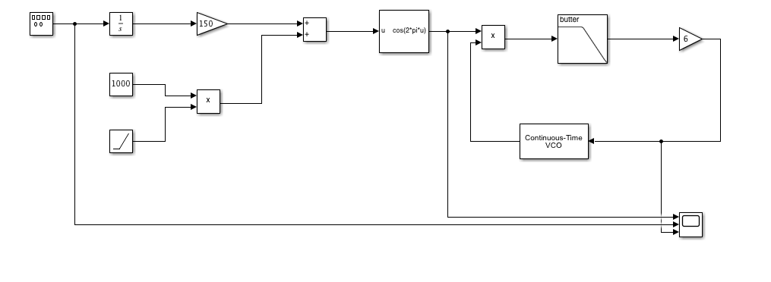

**Continuous Time VCO block:**

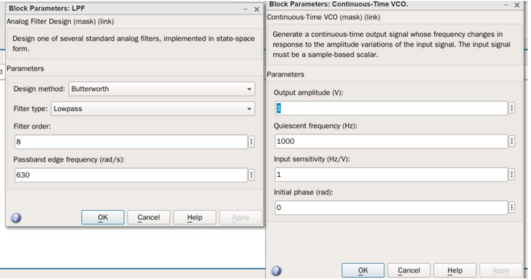

In this task, we will change the frequency of the message signal m (t) four times at two different amplitudes. We will start at Amplitude = 2.

**Using Frequency 50Hz**

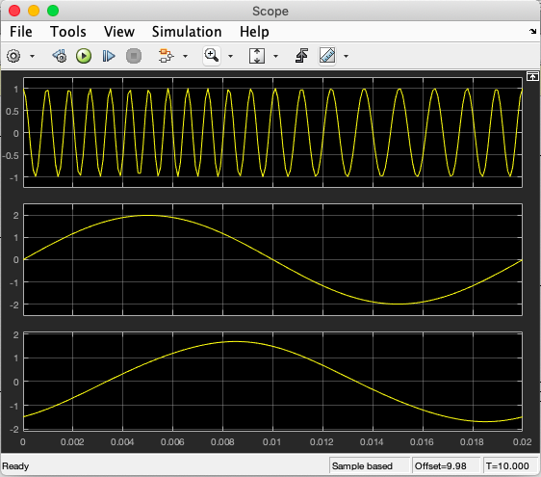

**Using Frequency 200Hz**

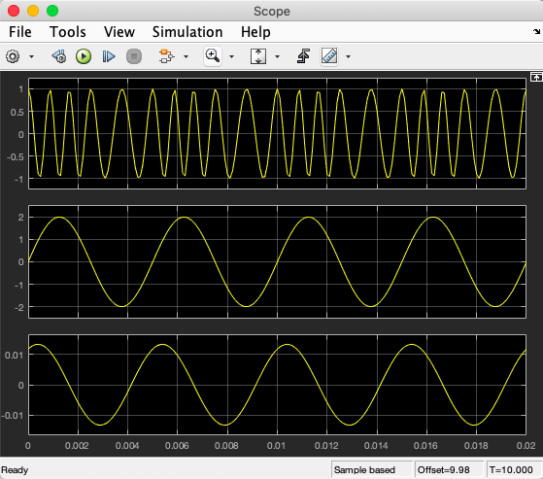

**Using Frequency 500Hz**

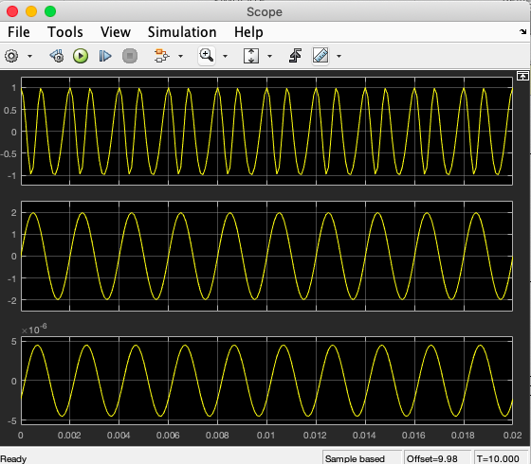

**Using Frequency 1000Hz**

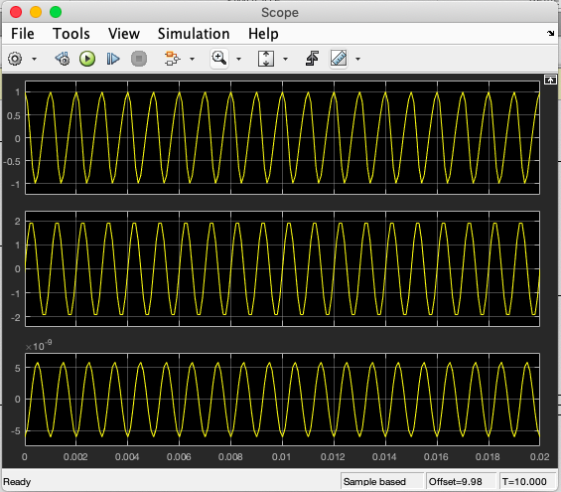

We will change the frequency at amplitude (4)

**Using Frequency 50Hz**

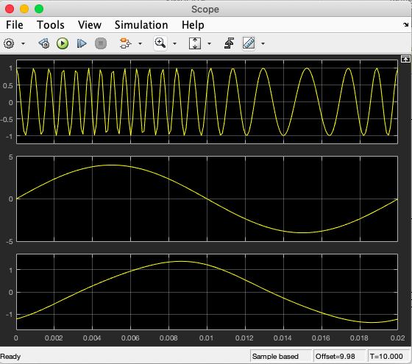

**Using Frequency 200Hz**

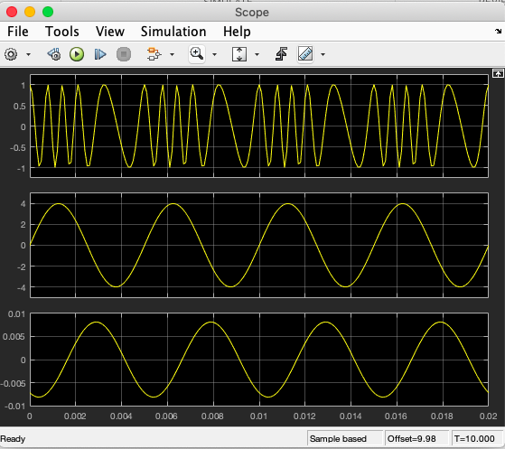

**Using Frequency 500Hz**

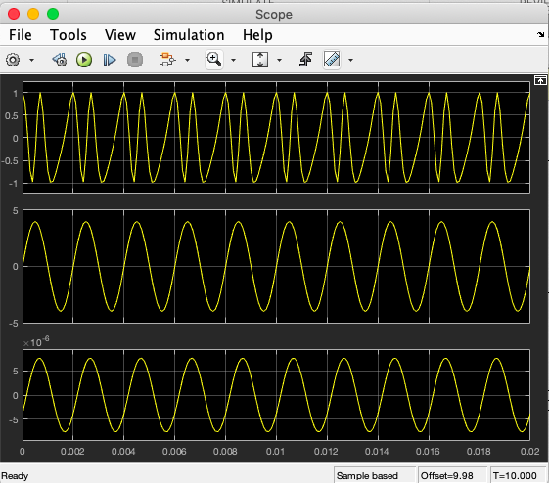

**Using Frequency 1000Hz**

